1. What is mechatronics? Explain multidisciplinary scenario
2. Explain filtering process with types of filters.
3. Draw a logic diagram to meet following conditions:

Coffee/Tea vending machine

1) System dispenses tea or coffee when the appropriate button is pressed

2) AND logic will check for money input criteria and required drink.

3) If by mistake both buttons are pressed (coffee and tea) machine should dispense tea.

1. Write a note on basic electrical components used in Mechatronics System.
2. Mention differences between hydraulic & pneumatic systems.
3. Draw the timing diagram for following timer instruction bit

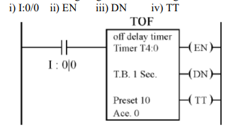

1. Construct a ladder diagram for the objective given below:

Fill the tank with liquids A and B

Heat and Stir the liquid for three minutes

Empty the tank

Repeat the cycle

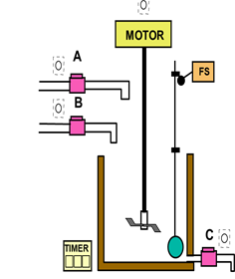

1. Draw & explain the programmable logic controller program scan.
2. List any four logical and arithmetic instructions in PLC
3. Draw ladder dia. For all gates
4. Mechatronics is a synergy of several engineering disciplines”- explain with example
5. Provide an overview of two types of temperature sensors that could be used in mechatronic systems, identifying the advantages and disadvantages of each and the temperature range that it can measure
6. Explain working of DAC with suitable block diagram & truth table.
7. Give full classification of control valves used in fluid system
8. Prepare a ladder diagram for automatic mixing process in industry from the description given below:

Material A and Material B are collected in a tank. These materials are mixed for a while. Mixed product is then drained out through Outlet valve. Implement this in PLC using Ladder Logic programming language.

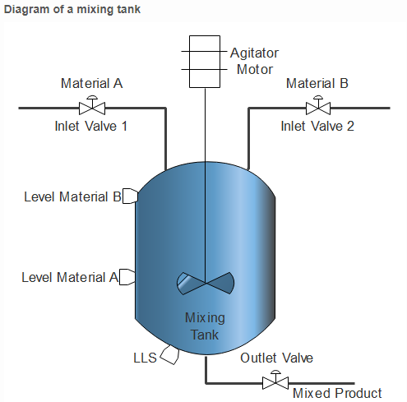

Figure:4

**Problem Description**

1. To detect level of Material A and Material B, two separate level switches are used. To detect low level, one more level switch is used at the bottom of the tank.
2. These give output in digital terms that is when corresponding levels are detected.
3. To control level of this system, Single Acting Piston valve can be used which has two states, either fully open or fully close.
4. To control mixing, agitator is used which is connected with Motor shaft.
5. Particular time delay is generate to mix the materials for a definite time.
6. Control inlet valves on the basis of Level Material switches A and B.
7. Outlet valve is then operated to drain the mixed product.

Draw PLC ladder logic diagram to control mixing in the tank.

1. Output 100 is to be ON only when either input 7 or 8 are ON or if input 17and input 18 are ON. Output 100 can be ON when all four inputs are ON. Draw ladder relay and PLC logic.
2. Explain the instruction TON and TOFF.
3. Find the response of first order system subjected to unit step and unit ramp input.
4. Draw circuit of voltage follower & derive equation.
5. Draw and explain two pump unloading circuit
6. Draw and explain following ckts

Meter in CKT

Meter out CKT

Bleed off CKT

1. Explain with block diagram-Programmable Logic Controller.
2. Explain symbols used in Programmable Logic Controller.
3. Explain how holding registers are used in timers.
4. Mention differences between hydraulic & pneumatic systems
5. State any four types of accessories used in pneumatic system along with their function.
6. Explain timers ,counters
7. There are three mixing devices on processing line (A, B and C)

When start is pressed mixer A goes on after 5 second delay

Next B is to start 10 seconds after A

Mixer C starts 12 seconds after B

All remains on until master switch is OFF. Develop a ladder logic.

1. Give comparison between computer-controlled systems & PLC controlled systems.
2. Draw a ladder diagram for 3 motor operation for following condition: i) Start push button starts motor M1. After 15 seconds M2 and M3 starts ii) Stop push button stops M3 and after 15 seconds motor M2 and M1